Rise and Shine, it’s Breakfast Time BINGO

Dear Parent/Guardian,

This month your child has been learning about the importance of eating a healthy breakfast. Now we are encouraging students to take the healthy learnings home.

The Rise and Shine, it's Breakfast Time home challenge encourages you and your child to try out some quick and healthy breakfast options that have been adapted from Alberta Health Services’ Wake Up to Breakfast Every Day. ¹ This activity provides some breakfast ideas that are delicious and nutritious – a great way to start the day!

Here is how you and your family can participate:

- Encourage your child to choose an option from the BINGO card below that they think sounds yummy, and have them try that out. You can make it an opportunity to connect, and work together to make the food!
- Initial each square that you and your family try.
- Aim to eat four breakfast options from the same row or column in the next two weeks to get a BINGO!
- Once you have completed a row, have your child bring in their BINGO card to school for their class to get the chance to participate in a class reward!

¹https://www.albertahealthservices.ca/assets/info/nutrition/if-nfs-wake-up-to-breakfast.pdf
Rise and Shine, it’s Breakfast Time!
Here are some quick and healthy breakfast ideas. Complete a row and bring your BINGO card to school to be entered for a draw!
*Be sure to check out our Taste Testing for new vegetable and fruit ideas
Whole grain hot or cold cereal with fruit and low fat milk (skim, 1%, or 2% Milk Fat)  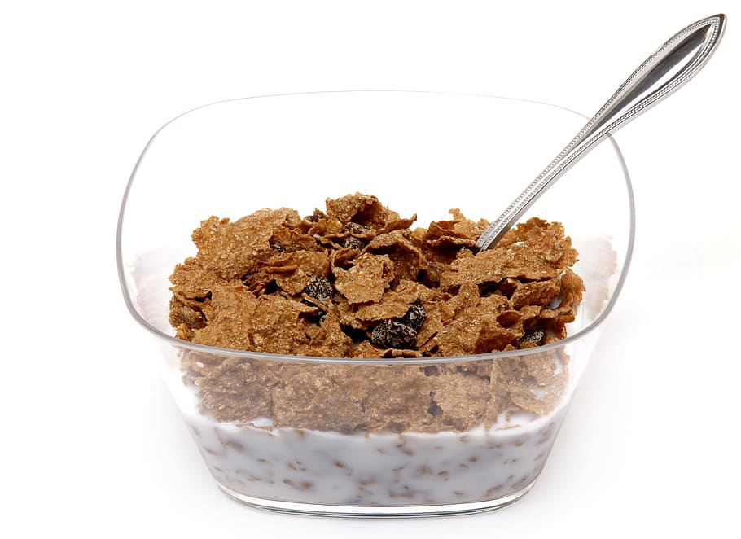 | Whole grain toast or bagel topped with peanut butter and sliced banana | Whole grain pancake topped with fruit and low fat yogurt (1%, or 2% Milk Fat) | Whole grain crackers, lower fat cheese (less than 20% Milk Fat), and an apple
A small oatmeal muffin, low fat yogurt, and an orange | Unsalted nuts mixed with dry whole grain cereal, and a piece of fruit  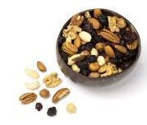 | Leftovers: homemade pizza, soup, pasta, or casserole | Whole grain toast  and a smoothie  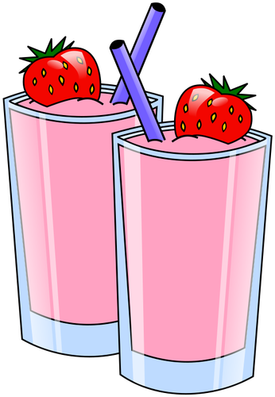
Scrambled eggs with vegetables (Microwave it for 1 - 1 ½ minutes to cook it)  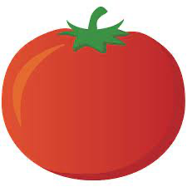 | A whole grain tortilla topped with scrambled eggs and lower fat cheese | A small whole grain bagel toasted and topped with ham and sliced tomato  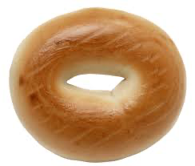 | A whole grain pita stuffed with cottage cheese and chopped fruit
Peanut butter spread on a whole grain tortilla, rolled up with a banana | A whole grain pita stuffed with tuna, chopped tomatoes, and lettuce | Oatmeal and milk with peanut butter and cinnamon mixed in, topped with raisins | Canned peaches or frozen berries mixed with low fat yogurt and whole grain cereal  