Family Olympics Challenge

Dear Parent/Guardian,

The Olympics are here, and our school is celebrating! Join us with your family and participate in a home activity called Family Olympics Challenge.

The Family Olympics Challenge presents a fun and active way to bring the games home and enjoy the event – you will do exercises based on the real games!

Encourage your child to lead this activity for your family. Embrace this fitness challenge to increase your heart rate, try different exercises, and have fun!

Here is how it works:

- Review the different exercises in the Olympics Activity sheet (attached), which have been modelled after Winter Olympics events.
- Gather as many family members as you can and spend 3 nights a week for the next 3 weeks completing all of the listed exercises for each session.
- You will begin with the Opening Ceremonies warm up (explained below). Once everyone is warm you will move together through each of the listed exercises until you have completed each exercise once. Don’t forget to stretch afterwards!
- Use the tracking sheet (attached) to write down the names of people who participated. Do this for each session. Have the parent/guardian initial by each day.
- After the 3 weeks, your child must bring the tracking sheet to school to give to their teacher.

Family Olympics Tracker

Name:___________________________

Week | Day 1  Participant Names | Day 2  Participant Names | Day 3  Participant Names
Week 1

Initials:
Week 2

Initials:
Week 3

Initials:

Olympics Activity

Opening Ceremonies Walk/Jog:
Perform a 5-10min walk/jog to warm up. Walk up & down stairs to increase the intensity or perform 20-30min of a walk/jog to challenge your heart and lungs.

Mogul Hops Skeleton Lift Luge Sit
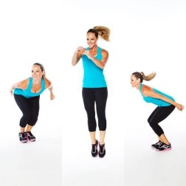
Perform 4-10 Lift & Hold for 2 sec. 4-10x’s Lift & Hold for 15, 30 or 60 sec
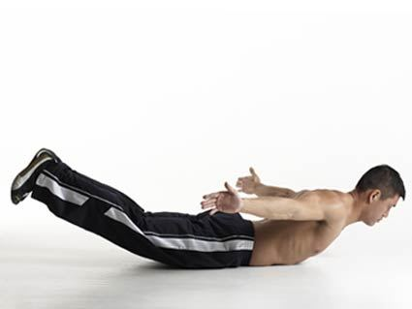

The Spiral Curlers Lunge The Hockey Twist
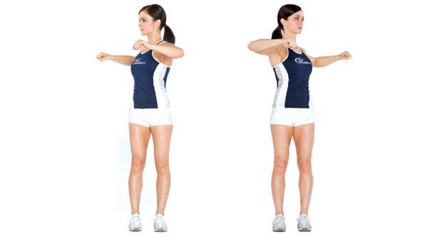
Balance for 5-10 breaths each side Perform 6-12 each side Perform 6-12 each side
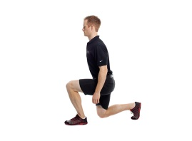
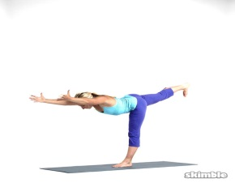

Aerial Jump The Star Lift Cross Country Ski
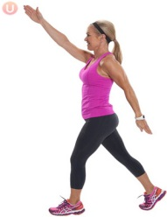
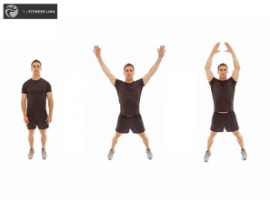
Jump & Strike a pose mid-air 4-8 x’s Lift & hold for 10, 20, or 30 sec Perform 6-20 each side

Bobsledder Shuffle Speed Skater Squat Downhill Squat Hold
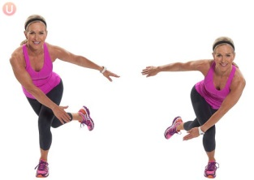
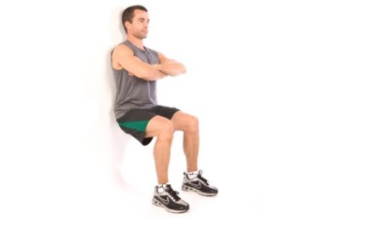
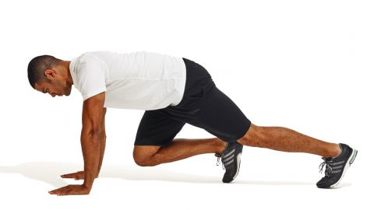
Perform 4-10 each side Perform for 40 sec or 60 sec Hold for 20, 40 or 60 sec

