50 Ways to Take a Break

This staff wellness initiative encourages school staff to take breaks throughout the day. It is easy to get wrapped up in the day-to-day of school life so being mindful of taking time to breathe is important! Taking active or thoughtful breaks can improve well-being and model healthy behaviours for students.

Other potential benefits of taking breaks throughout the day include:

- Increase in energy
- Increase in work engagement
- Better overall health and vitality

Timeline:
It should take about one month to complete all 50 Ways to Take a Break collectively as a staff.

Goal:
To have everyone on staff complete the 50 Ways to Take a Break activities as a team. Ideally, each staff member should participate in at least one break.

Materials:
- Email to staff (attached)
- Display materials (attached)
- Scissors, and glue or tape

Instructions:
- Create and post the 50 Ways to Take a Break poster in the staff room or in a hallway where students can see staff progress.
  - Refer to the original poster created by Karen Horneffer-Grinter (attached) to see an example of the display layout.
  - Cut out the attached photos and text, including the title, to create your display. The picture samples provided were used by the APPLE Schools team when we ran this initiative in our office.
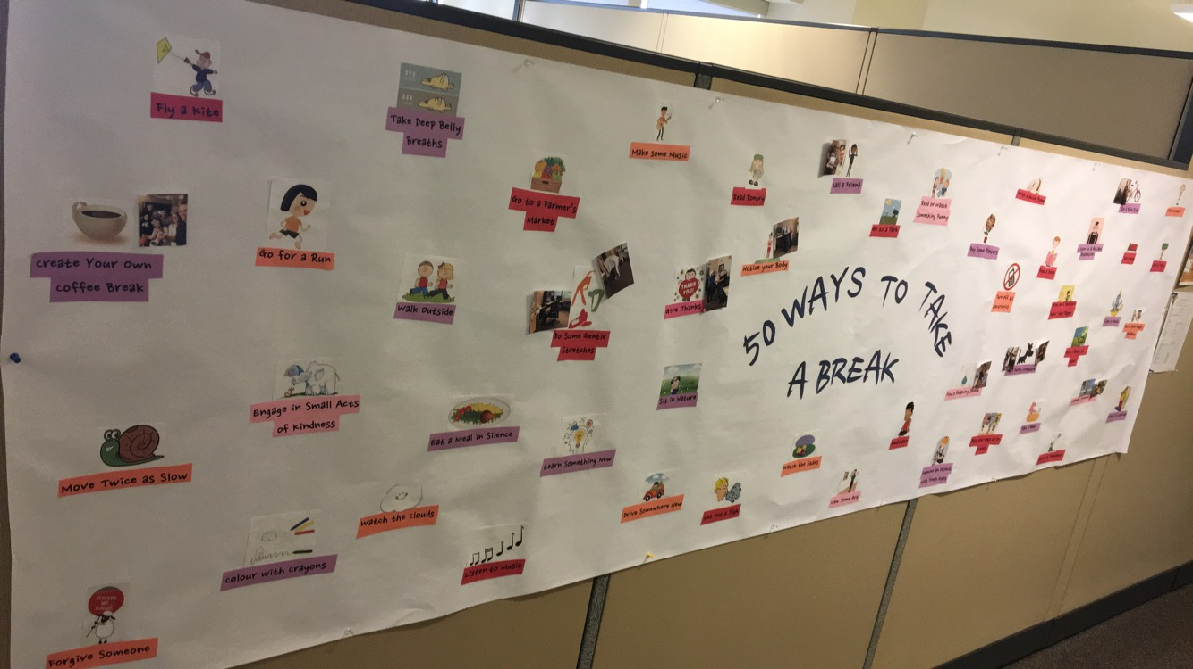
- Post photos of yourself participating in one or two of the breaks to role model to staff members how this challenge works.
- Send out email explaining the staff wellness challenge to staff (attached).
- When a staff member successfully participates in a break activity and sends you a photo, post it on the challenge display. Send out email reminders to your staff to send you their photos, or to post the photos themselves.
- Encourage staff to have fun with the photos and create new ways to take a break if their favorite is not listed.

Next Steps:
- Once your display has some staff engagement, take a photo of it and share it on Twitter and/or Facebook. Please tag @APPLESchools so that we can re-post!
- Continue the momentum of caring for mental health:
  - Encourage taking breaks, even after the activity has ended.
  - Check out any of the APPLE Schools mental-health-focused monthly campaigns, like Address Your Stress, Unwind Your Mind, or Power of Positivity.
  - Refer to APPLE Schools’ Mental Health Bin, which has many breathing and reflection activities that staff could try in their classrooms.
Suggested staff email copy

Please personalize as you see fit.

Hello (school name) staff,

As school staff, we know how easy it is to forget to take much-needed breaks during the day -- that’s why I am inviting you all to take a breather with a new staff wellness challenge.

50 Ways to Take a Break will encourage us to take active or thoughtful breaks to improve well-being and model healthy behaviour for students. The ultimate goal is to make mental health a priority in our busy lives.

  - Check out the 50 Ways to Take a Break display located in (location).
  - Snap a photo of you doing the take-a-break activities listed on the poster.
  - Print the photo and stick it on the poster or email the photo to me and I will post it for you.

The display will be posted until (length of time chosen) and I hope that by the end, each and every one of you will have taken some time to take at least one break (with an accompanying photo), because you deserve it!

Original poster by Karen Horneffer-Grinter. Use for reference. 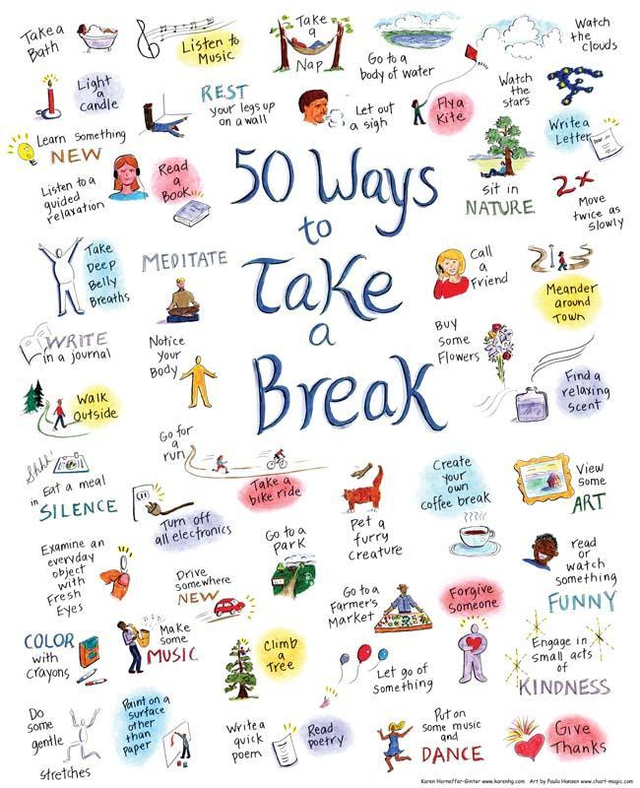

Images and text to cut and glue to display:
50 Ways to Take a Break

Learn Something New

Listen to a Guided Relaxation

Walk Outside

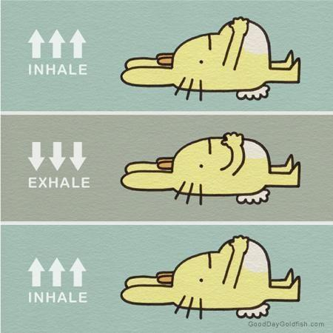
Write in a Journal

Take Deep Belly Breaths

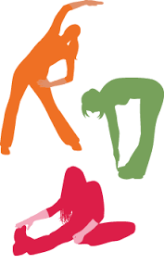
Do Some Gentle Stretches

Colour with Crayons
Rest Your Legs on a Wall
Eat a Meal in Silence

Read a Book

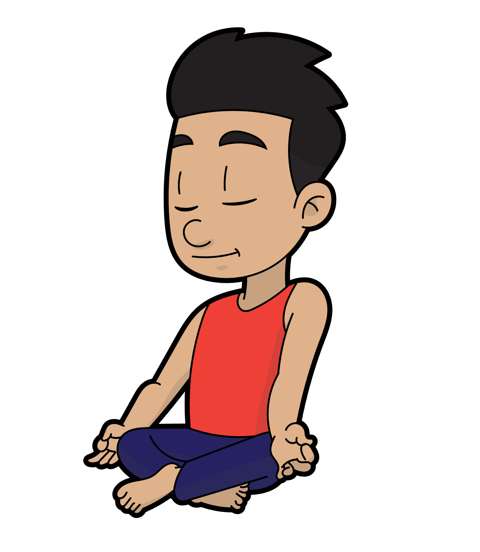
Meditate
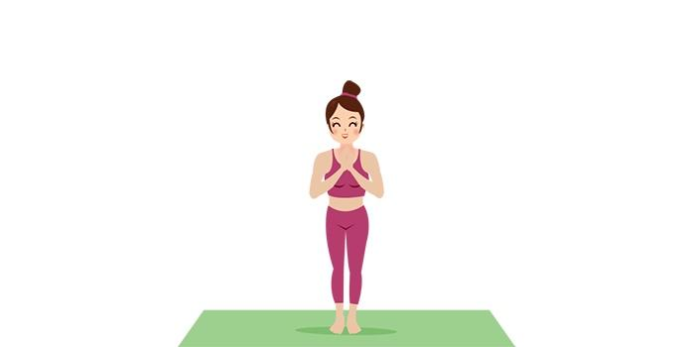
Notice Your Body

Go for a Run

Examine an Object with Fresh Eyes

Make Some Music

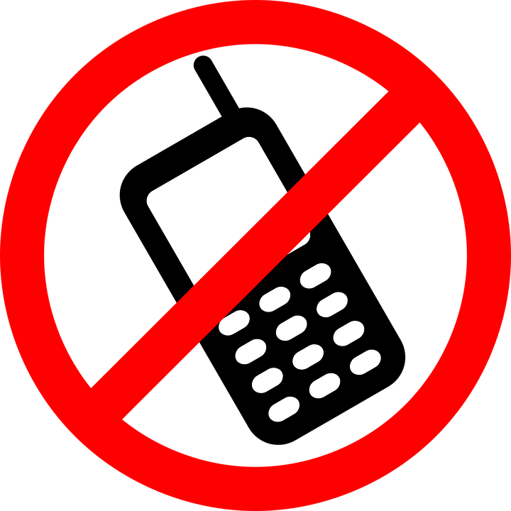
Turn off all Electronics

Listen to Music

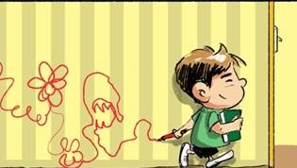
Print on a Non-Paper Surface

Take a Nap

Let Out a Sigh
Drive Somewhere New

Sit in Nature
Visit a Body of Water

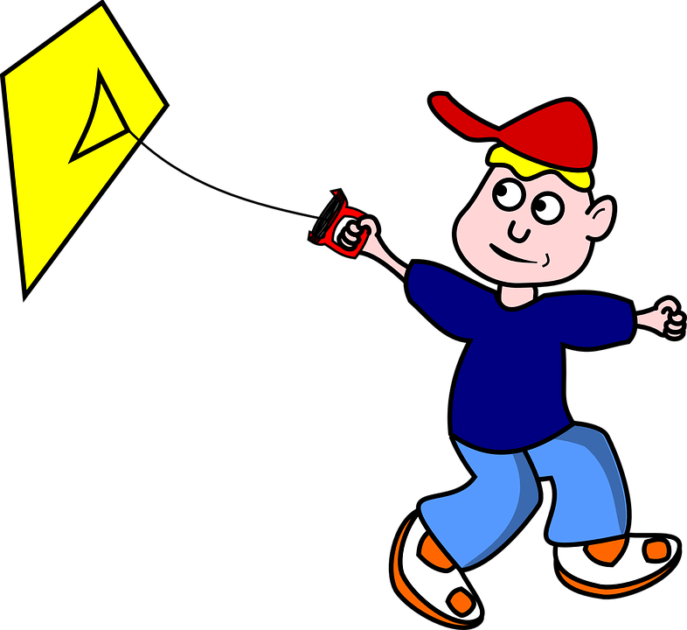
Fly a Kite

Call a Friend

Buy Flowers

Take a Bath
Have a Coffee Break

Light a Candle

Pet a Furry Creature

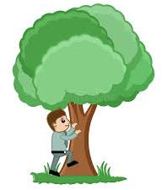
Climb a Tree

Write a Quick Poem

Read Poetry

Forgive Someone

Go to a Farmer’s Market

Watch the Stars

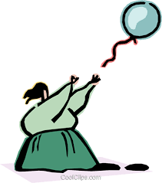
Let go of Something

Watch the Clouds

Put on Some Music and Dance

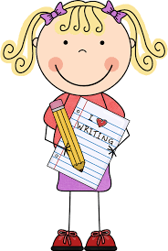
Write a Letter

Move Twice as Slow

View Some Art

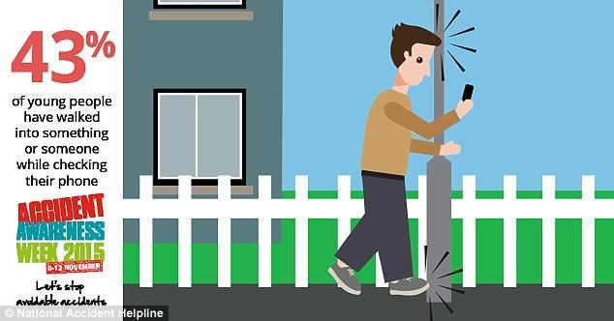
Meander Around Town

Read/Watch Something Funny

Engage in Small Act of Kindness

Find a Relaxing Scent

Give Thanks
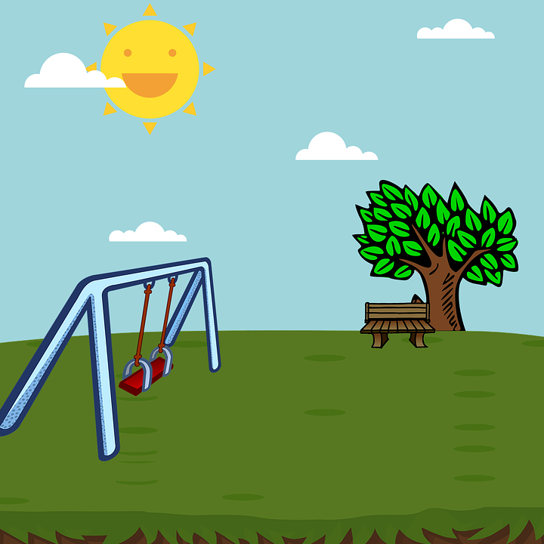
Visit a Park
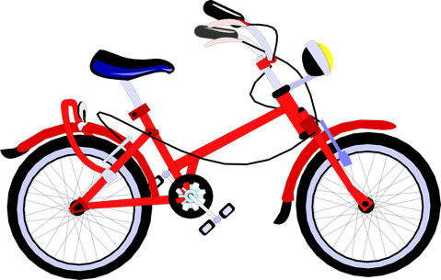
Have a Snack

Take a Bike Ride

Blasche G, Szabo B, Wagner‐Menghin M, Ekmekcioglu C, Gollner E. Comparison of rest‐break interventions during a mentally demanding task. Stress and Health. 2018;1–10. Doi: 10.1002/smi.2830
Kühnel, J., Zacher, H., de Bloom, J., & Bledow, R. (2017). Take a break! Benefits of sleep and short breaks for daily work engagement. European Journal Of Work & Organizational Psychology, 26(4), 481-491. doi:10.1080/1359432X.2016.1269750

